# C O M P 3 0 8 / S p r i n g 2 0 2 3

**A S S I G N M E N T # 4 : N E T W O R K L A Y E R**

**P R O B L E M S**

**P1. DIJKSTRA'S LINK STATE ALGORITHM – ADVANCED [15pt]**

Consider the incomplete 6-node network shown below, with the given link costs.

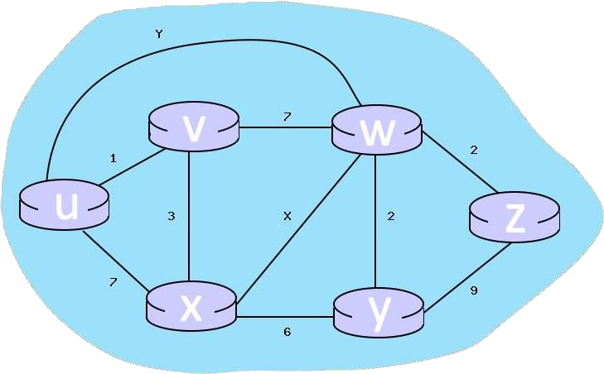

Consider the completed table below, which calculates the shortest distance to all nodes from W:

================================================

| Node | Shortest distance from W | Previous Node |

================================================

|  |  |  |
| --- | --- | --- |
| W | 0 | n/a |
| Y | 2 | W |
| Z | 2 | W |
| V | 7 | W |
| X | 7 | W |
| U | 8 | W |

================================================

1. For link X, what is the cost associated with this link? If the answer can't be determined given the information, respond with 'n/a'

X = 7

1. For link Y, what is the cost associated with this link? If the answer can't be determined given the information, respond with 'n/a'

Y = 8

# P2. BELLMAN FORD DISTANCE VECTOR ALGORITHM (FOR COMPUTING LEAST COST PATHS) [15pt]

Consider the 6-node network shown below, with the given link costs:

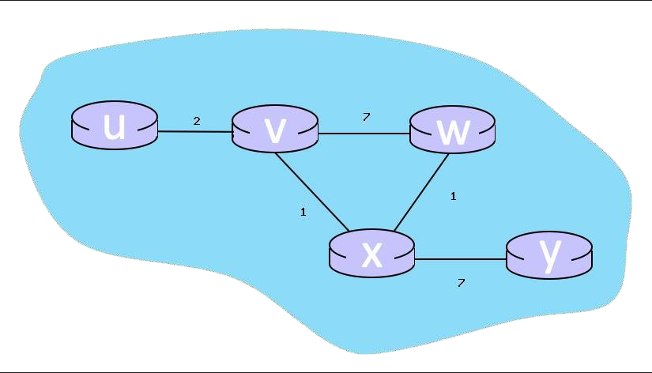

1. When the algorithm converges, what are the distance vectors from router 'W' to all routers? Write your answers in order: (u,v,w,x,y)

(4,2,0,1,8)

1. What are the initial distance vectors for router 'X'? Write your answer as u,v,w,x,y and if a distance is ∞, write 'x'

(x,1,1,0,7)

# P3. LONGEST PREFIX MATCHING [10pt]

Consider a datagram network using 8-bit host addresses.

Suppose a router uses longest-prefix matching, and has the following forwarding table:

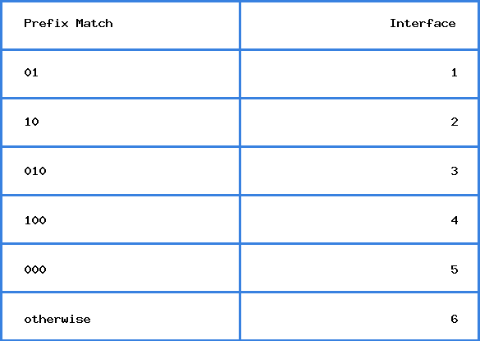

# QUESTION LIST

1. Suppose a datagram arrives at the router, with destination address 10001110. To which interface will this datagram be forwarded using longest-prefix matching?

4

1. Suppose a datagram arrives at the router, with destination address 11101111. To which interface will this datagram be forwarded using longest-prefix matching?

6

1. Suppose a datagram arrives at the router, with destination address 00011000. To which interface will this datagram be forwarded using longest-prefix matching?

5

**P4. NETWORK ADDRESS TRANSLATION [30pt]**

Consider the scenario below in which three hosts, with private IP addresses 10.0.1.12, 10.0.1.17, 10.0.1.19 are in a local network behind a NAT'd router that sits between these three hosts and the larger Internet. IP datagrams being sent from, or destined to, these three hosts must pass through this NAT router. The router’s interface on the LAN side has IP address 10.0.1.28, while the router’s address on the Internet side has IP address 135.122.193.211.

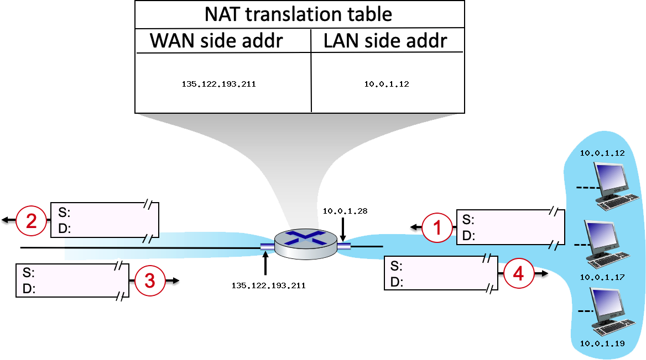

Suppose that the host with IP address 10.0.1.15 sends an IP datagram destined to host 128.119.166.186. The source port is 3421, and the destination port is 80.

* 1. Consider the datagram at step 1, after it has been sent by the host but before it has reached the router. What is the **source IP address** for this datagram? At step 1, what is the **destination IP address**?

source IP address: 10.0.1.15

destination IP address: 128.119.166.186

* 1. Consider the datagram at step 2, after it has been transmitted by the router. What is the **source IP address** for this datagram? At step 2, what is the **destination IP address** for this datagram? Will the **source port** have changed? Yes or No.

source IP address: 135.122.193.211

destination IP address: 128.119.166.186

yes, the source port will be changed.

* 1. Consider the datagram at step 3, just before it is received by the router. What is the **source IP address** for this datagram? At step 3, what is the **destination IP address** for this datagram?

source IP address: 128.119.166.186

destination IP address: 135.122.193.211

* 1. Consider the datagram at step 4, after it has been transmitted by the router but before it has been received by the host. What is the **source IP address** for this datagram? At step 4, what is the **destination IP address** for this datagram.

source IP address: 128.119.166.186

destination IP address: 10.0.1.15

# P5. PACKET SCHEDULING [30pt]

Consider the arrival of 15 packets to an output link at a router in the interval of time [0, 5], as indicated by the figure below. We’ll consider time to be “slotted”, with a slot beginning at t = 0, 1, 2, 3, etc. Packets can arrive at any time during a slot, and multiple packets can arrive during a slot. At the beginning of each time slot, the packet scheduler will choose one packet, among those queued (if any), for transmission according to the packet scheduling discipline (that you will select below). Each packet requires exactly one slot time to transmit, and so a packet selected for transmission at time t, will complete its transmission at t+1, at which time another packet will be selected for transmission, among those queued. You might want to review section 4.2.5 in the 8th edition of our textbook, on packet scheduling.

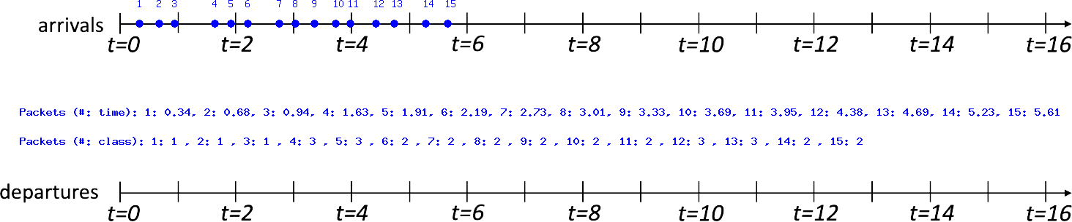

Choose a specific packet scheduling discipline (First Come First Serve (FCFS), Priority, Round Robin (RR)) from the list below. In the case of Priority and RR, there will be three classes of traffic (1, 2, 3), with lower class numbers having higher priority in the case of priority schedule, or beginning earlier in the case of RR.

* + 1. For **FCFS**, at t = [1,2,3,4,5,6,7,8,9,10] which packet is sent out at each t? Give the packet # or 'n/a' if applicable.

**Order of packets:** [1,2,3,4,5,6,7,8,9,10,11,12,13,14,15]

Till t=10 all the packets will arrive but considering the transmission of each packet is t+1 answer will be the first arrived 10 packet

[1,2,3,4,5,6,7,8,9,10]

* + 1. For **Priority**, at t = [1,2,3,4,5,6,7,8,9,10] which packet is sent out at each t? Give the packet # or 'n/a' if applicable.

**Order of packets:** [1,2,3,6,7,8,9,10,11,14,15,4,5,12,13]

Till t=10 all the packets will arrive but considering the transmission of each packet is t+1 answer will be changed regarding their priorities:

[1,2,3,6,7,8,9,10,11,14]

* + 1. For **RR**, at t = [1,2,3,4,5,6,7,8,9,10] which packet is sent out at each t? Give the packet # or 'n/a' if applicable

**Order of packets:** [1,4,2,6,5,3,7,12,8,13,9,10,11,14,15]

Till t=10 all the packets will arrive but considering the transmission of each packet is t+1 answer will be changed regarding their priorities:

[1,4,2,6,5,3,7,12,8,13]